Safeguarding Policy 2024 All Saints Wellington with St Catherine’s Eyton

The PCC will take all reasonable care to ensure the safety of the children, young people, and vulnerable adults for whom it bears responsibility, as detailed in the House of Bishops policy statement, “Promoting a Safer Church”. In light of this responsibility, the PCC adopts the following procedures, in addition to the national Safeguarding Learning and Development Framework, and Social Media policies. In line with Diocesan policy the PCC commits to operate in line with all Diocese and national level policies on Safeguarding.

Organisational
- Angela Bruno is our approved Safeguarding Lead for the calendar year 2024. The
Safeguarding Lead has responsibility for monitoring compliance with this policy, facilitating DBS checks, and keeping all records of DBS Checks. This person may have one or more assistants who help with the administration of these tasks. The Safeguarding Lead, if not an elected member of PCC will be appointed ex officio to the PCC.
- Angela Bruno is our approved Child Protection Officer for the calendar year 2024. She is the point of contact through which concerns about child protection will be channelled.
- Angela Bruno is our approved Vulnerable Adult Protection Officer for the calendar year 2024. She is the point of contact through which concerns about vulnerable adult protection will be channelled.

DBS Checks
- In line with Diocesan Policy, all members of the PCC will be subject to DBS checks.
- Leaders aged 18 or over working with children, young people, or vulnerable adults, in a DBS eligible role, will be required to undergo a DBS check as a condition of their post. Validated leaders of a group must be aged 18 or over and have undergone a DBS check, if eligible. New applicants must wait until the diocese has notified the incumbent of the disclosure result before the applicant starts to work with children or vulnerable adults.
- In line with Diocesan Policy, the PCC no longer accepts that DBS checks are portable from other organisations. A check made through the church will be required for future applicants.
- The Safeguarding Lead will maintain a list of those with DBS checks and will undertake regular reviews of the DBS checks to ensure that they are up-to-date. In line Diocesan Policy, this includes the resubmission of individuals for a further DBS check every 3 years.

PCC Obligations
- Safeguarding will be a standing item on the PCC agenda.
- The PCC will ensure that the buildings in which church-run groups meet in are safe and in good repair.
- The PCC will carry public liability insurance and will insure all leaders and staff for personal accident.
- The PCC will publish on the notice boards at the back of church and in the Parish Hall, a copy of the Diocesan Child Protection Flow Chart (Appendix 5) and a copy of the Vulnerable Adult Suspected Abuse Flow Chart (Appendix 1). In addition, all validated leaders will be given a copy. If a case of abuse is suspected, this will be the procedure followed.
- In line with Diocesan policy all members of PCC will undertake Basic, Foundation and Awareness of Domestic Abuse safeguarding training renewable every three years.

Compliance and Review
- This Policy and its procedures will be monitored by the Safeguarding Lead who will report to the PCC annually.
- The PCC will review the policy and its procedures annually.

Safeguarding Children and Young People

The PCC adopts the principles of the Child Protection Policy Statement of the Church of England
(House of Bishops Protecting all God’s Children 2010:4): We are committed to:
- The care, nurture of, and respectful pastoral ministry with, all children and all adults
- The safeguarding and protection of all children, young people and adults when they are vulnerable
- The establishment of safe, caring communities which provide a loving environment where there is a culture of “informed vigilance” as to the dangers of abuse.
We will carefully select and train all those with any responsibility within the Church, in line with safer recruitment principles, including the use of criminal records disclosures and registration with the relevant vetting and barring schemes.
We will respond without delay to every complaint made which suggests that an adult, child or young person may have been harmed, co-operating with the police and local authority in any investigation.
We will seek to work with anyone who has suffered abuse, developing with him or her an appropriate ministry of informed pastoral care.
We will seek to challenge any abuse of power, especially by anyone in a position of trust. We will seek to offer pastoral care and support, including supervision and referral to the proper authorities, to any member of our church community known to have offended against a child or young person.
In all these principles we will follow legislation, guidance and recognised good practice.

Procedures
In the light of this policy the PCC adopts the following procedures:

- The PCC is directly responsible for all church-run groups which include children and young people.
- The PCC requires all church-run groups which include children and young people to keep a register of all children, young people and adults present at every meeting and to provide to the Safeguarding Lead and Children’s and Youth Worker a list of its current leaders, details of their roles, and information on when and where the group meets, its normal working pattern and the age range it covers.
- The PCC requires all groups which regularly use church property to have an appropriate Child Protection policy, a copy of which will be given to the Safeguarding Lead.
- For Sunday morning CYPECS groups, the PCC requires parents (or an adult designated by the parents) to collect children (up to and including Y5) from groups, unless the children are brought by the leaders back into church. Young people’s groups (Y6 upwards) may allow the young people to leave unaccompanied, provided parental consent has been obtained.
- Every third year safeguarding training will be required for all working with children to Foundation level. The PCC, through the Children’s and Youth Worker, will also make available other appropriate training as necessary.
- The PCC adopts the Diocesan staffing procedure of a minimum of two validated leaders present for every activity and will follow the following minimum ratios: for 0-2 years 1 validated leader to 3 children, for 2-3 years 1 validated leader to 4 children, and for 3 years upwards 1 validated leader to 8 children/young people.
- A convicted sex offender will be welcomed as a member of our church community, provided they have signed and keep to a suitable agreement (see Appendix 4). This agreement shall be agreed and signed by the Vicar, the offender and their probation officer and will be drawn up with advice from the Bishop and the Diocesan Safeguarding Adviser. The confidentiality of the offender shall be respected, although the staff team, church wardens and Safeguarding Lead shall be notified.
Sources:
Protecting All God’s Children: The Policy for safeguarding Children in the Church of England (4th edn.) 2010. Church House Publishing.
Available from: https://www.churchofengland.org/sites/default/files/2017-11/Protecting%20All%20God%27s%20Children%204th%20edition.pdf

Promoting a Safer Church
Available from: https://d3hgrlq6yacptf.cloudfront.net/5f3ffdd147bb3/content/pages/documents/fee3a91ee26d4d10983056a7a5577da3d9a80324.pdf

Lichfield Diocesan Safeguarding Policy 2021
Available from:https://d3hgrlq6yacptf.cloudfront.net/5f3ffdd147bb3/content/pages/documents/diocese-safeguarding-policy-and-guidance-2021-v22.pdf

Vulnerable Adult Safeguarding

- We recognize that everyone has different levels of vulnerability and that each of us may be regarded as vulnerable at some time in our lives.
- As members of this parish we commit ourselves to respectful pastoral care for all adults to whom we minister.
- We commit ourselves to the safeguarding of people who may be vulnerable, ensuring their well-being in the life of this church. The PCC adopts the Government White Paper No Secrets (2000) definition of a vulnerable adult as somebody “who is or may be in need of community care services by reason of mental or other disability, age or illness and who is or may be unable to take care of him or herself, or unable to protect him or herself against significant harm or exploitation”. Examples of activities which may involve vulnerable adults are listed in Appendix 2
- We commit ourselves to promoting safe practice by those in positions of trust.
- The parish commits itself to promoting the inclusion and empowerment of people who may be vulnerable.
- It is the responsibility of each of us to prevent the physical, emotional, sexual, financial and spiritual abuse of vulnerable people and to report any such abuse that we discover or suspect.
- We undertake to exercise proper care in the appointment and selection of those who will work with people who may be vulnerable.
- The parish is committed to supporting, resourcing, training and regularly reviewing those who undertake work amongst people who may be vulnerable providing training jointly with children’s and young people’s leaders.
- The parish adopts the guidelines of the Church of England and the Diocese including Promoting a Safe Church and the Anglican Methodist Safe Recruitment Policy.
- Each person who works with vulnerable people will agree to abide by these recommendations and the guidelines established by this church.

Procedures
In the light of this policy the PCC adopts the following procedures:

- The current Diocesan Safeguarding Advisor is Neil Spiring, neil.spiring@lichfield.anglican.org; Tel: 01543 306147. In case of emergency, if immediate action needs to be taken then dial 999. Alternatively contact could be made direct with Telford and Wrekin Adult Safeguarding Team on 01952 385385 (option 3) (office hours) or (out of hours) the Emergency Duty Team 01952 676500. Then Angela Bruno and the Incumbent should be notified. In non-emergency cases contact Angela Bruno or the Incumbent to notify them.

- The PCC recognises that the alleged victim may not wish a particular incident or disclosure to be further investigated or reported to the police or social services. Adults who are able to make informed decisions have the right not to have the matter pursued. However consideration should be given to the seriousness of the suspected abuse and whether anyone else is being put at risk. Any allegation involving a member of staff, paid carer or volunteer must be investigated. A decision not to report the matter to the police or social services should be agreed with the vulnerable adult and recorded.

- All Saints has an active Causeway group providing fellowship, friendship and ministry to adults with learning difficulties/disabilities and accordingly the PCC has adopted the “Guidelines for Minimising Risk in Causeway Prospect Groups” published by the national organisation “Causeway Prospects” to which All Saints is affiliated. These guidelines are attached in Appendix 3.

4. Every third year safeguarding training will be required for all working with vulnerable adults to Foundation level. The PCC, through the Incumbent, will also make available other appropriate training as necessary.

Appendix 1

RESPONDING TO SUSPECTED ABUSE IN CHURCH SETTINGS

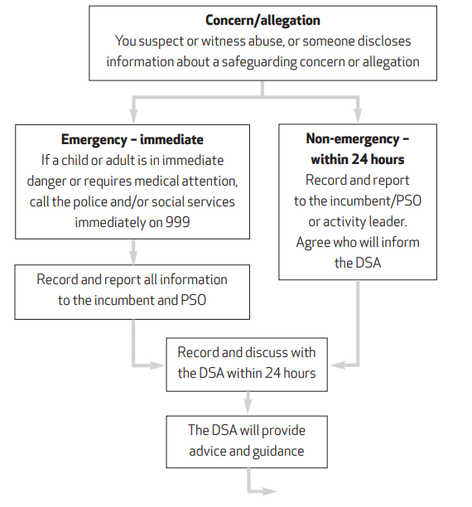
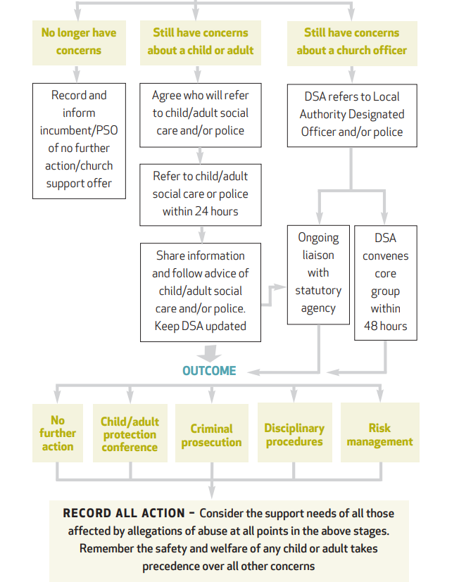

PSO – Parish Safeguarding Officer/Safeguarding Co-ordinator
DSA – Diocesan Safeguarding Adviser

Source: Parish Safeguarding Handbook 2018
Available from: https://d3hgrlq6yacptf.cloudfront.net/5f3ffdd147bb3/content/pages/documents/1595249440.pdf

Appendix 2
EXAMPLES OF ACTIVITIES WHICH MAY INVOLVE VULNERABLE ADULTS INCLUDE:

Oasis
Causeway Prospects (see specific guidance in Appendix 3)
Home Communions
Transport Rota
Pastoral Visiting
Homegroups
Bereavement ministry
Individuals presenting with acute needs in church, churchyard or parish centre
Church services and refreshments after church

Appendix 3

GUIDELINES FOR MINIMISING RISK IN CAUSEWAY PROSPECTS GROUPS AND IN CHURCH SETTINGS
The purpose of these guidelines is to minimise the risk of accident, injury and abuse in Causeway Prospects Groups, and to protect everyone involved. The guidelines are in the form of a summary of the possible risks and simple measures that can be taken to minimise risks. The list of examples given is not exhaustive, and groups should devise any other precautions which seem appropriate as they consider their own settings.

Accidents
Watch out for potentially dangerous items/incidents. If you spot anything, either do something about it or report it to someone who can take the necessary action. Examples of potential hazards:
- Exposed electrical wiring
- Projector (or other) cable trailing where people could trip over it
- Uneven ground where group members need to walk
- Risk of scalding with hot liquids

Physical or sexual abuse or allegations thereof
- All team members must obtain a DBS disclosure or equivalent
- (See appendix for appropriate contact details)
- Do not be alone with members other than the one(s) you normally bring to the group or support
- Do not assist anyone to the toilet (care staff should provide this help if needed)
- Do not use physical restraint of any sort
- Always have someone else with you if you give a lift to a group member
- Do not give lifts to someone you do not know

Psychological or discriminatory abuse or allegations thereof
- Always use positive, inclusive and age appropriate language
- Always be kind and tolerant in the way you speak to people
- Never respond to verbal abuse with verbal abuse
- Keep calm, speak quietly and gently
- Never lose your temper
- Have fun, but not at somebody else’s expense

Financial or Material abuse or allegations thereof
- Always ask somebody what assistance they need with their belongings – don’t ‘do for’ but
‘assist with’
- Never go into somebody’s purse or bag where they can’t see you.
- If somebody asks you to get some money out of their purse or wallet to pay for something then always show them what money you are taking out

Neglect and acts of omission or allegations thereof
- When someone new joins, have a carer (staff, friend or relative) stay with the person until you know them well enough to communicate effectively with them
- Make yourself aware of any specific medical needs, e.g. epilepsy, diabetes, so you can be prepared to support people appropriately
- Do not get involved in dispensing medication

Refreshments
- Make yourself aware of any special dietary needs
- Provide tables for people to rest drinks/plates on
- Do not overfill cups/mugs
- Provide special crockery/cutlery as necessary
Appendix 4

Agreement for a known sex offender

An agreement will be drawn up with the perpetrator, in consultation with the Diocesan Safeguarding Adviser (DSA), in recognition of the priority of the need to protect children and vulnerable adults. This may also avoid unnecessary exclusion of a known perpetrator and protect him/her from further allegations. Acceptance of such an agreement will be a precondition to membership of the congregation. The agreement will be sent to the Archdeacon and the DSA, and should be acceptable to them; where thought appropriate the statutory agencies (i.e. probation, police, SSD) will be invited to become involved.

The agreement must state:
- Who is to supervise the perpetrator.
- What risks the perpetrator poses to children and young people and how these are to be managed.
- Times and occasions when they can be on church premises.
- Which activities he/she can attend.
- That contact with children and young people is avoided.
- If unforeseen and accidental contact occurs, how it is to be dealt with.
- That they will not be a key holder to church premises.
- Who should be informed of his/her status, for example, leaders of a children’s group.
- If s/he should move away, how churches in the new area are informed.
- That the agreement is to be monitored and reviewed every 6 months by the supervisor and the perpetrator.

Suggested clauses for a possible agreement may include:
- I will never allow myself to be in a situation where I am alone with children/young people.
- I will attend meetings/house groups as directed by the church leadership.
- I will sit where directed in the church and will not place myself in the vicinity of children and young people.
- I will not enter certain parts of the building designated by the leadership, nor any area where children's activities are in progress. • I will decline invitations of hospitality where there are children in the home.
- I accept that "x" and "y" will sit with me during church activities, accompanying me when I need to use other facilities. They will know I am a Schedule 1 Offender/registered with the police under the terms of the Sex Offenders Act.
- I accept there are certain people who will need to be told of my circumstances in order for them to protect the children/young people for whom they care.
- I accept that contact will need to be made with my probation officer, who will meet with church leaders as and when necessary (where appropriate).
- I accept that "z" will provide me with pastoral care.
- I understand that if I do not keep to these conditions, then I may be barred from attending the church, and in such circumstances the leadership may choose to inform the statutory agencies (eg police, probation and social services) and any other relevant organisation, and the church congregation.
- I understand that any other concerns will be taken seriously and reported.
- I understand that this contract will be reviewed every 6 months and will continue indefinitely.

Signed: Date:

